# CS 255 System Design Document Template

This template lays out all the different sections that you need to complete for Project Two. Each section has guidance to prompt your thinking. You will need to continually reference the interview transcript as you work to make sure that you are addressing your client’s needs. There is no required length for the final document. Instead the goal is to complete each section based on what your client’s needs are. Remove this note when you are finished, and replace all bracketed text with the relevant information.

## UML Diagrams

### UML Use Case Diagram

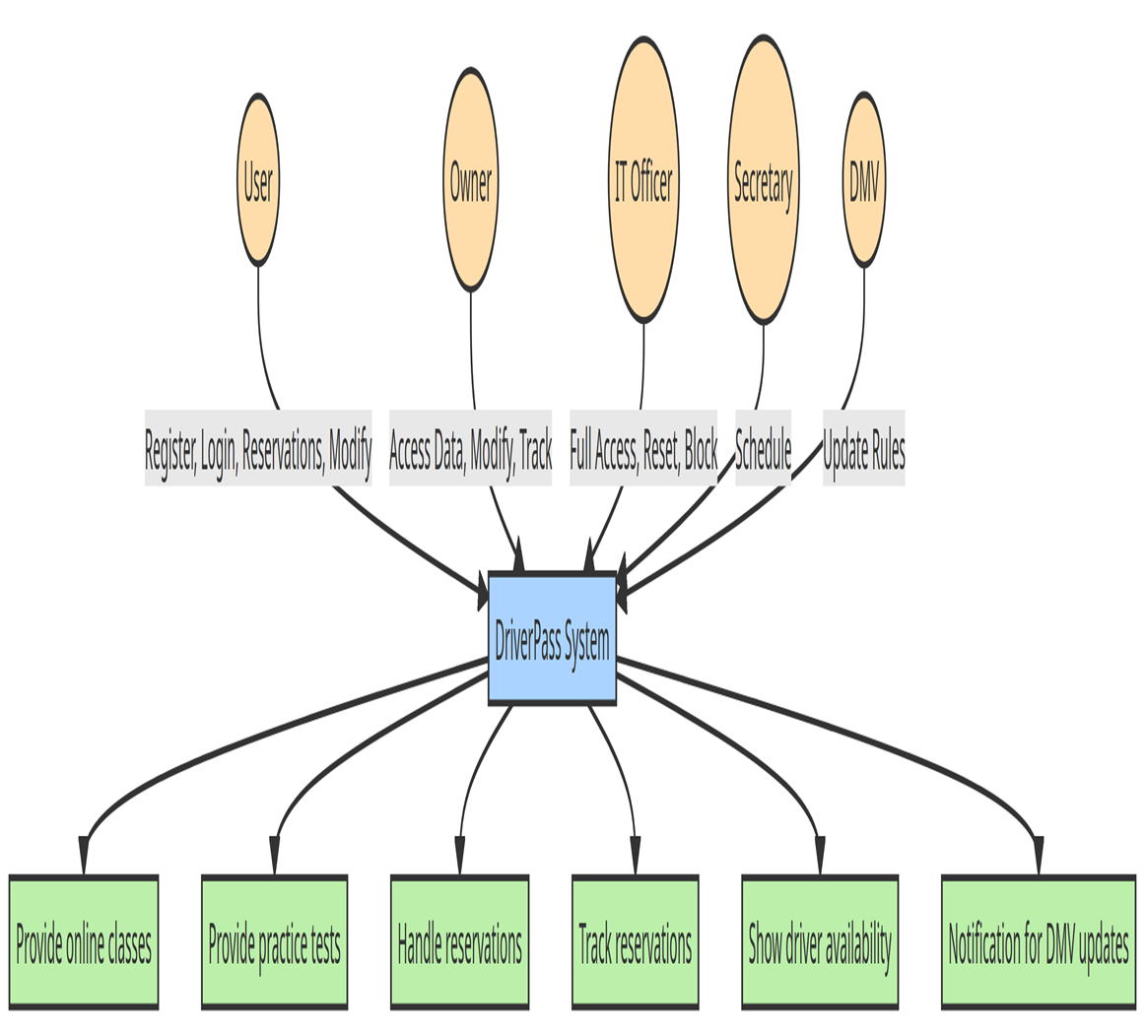

### UML Activity Diagrams

### UML Sequence Diagram

### UML Class Diagram

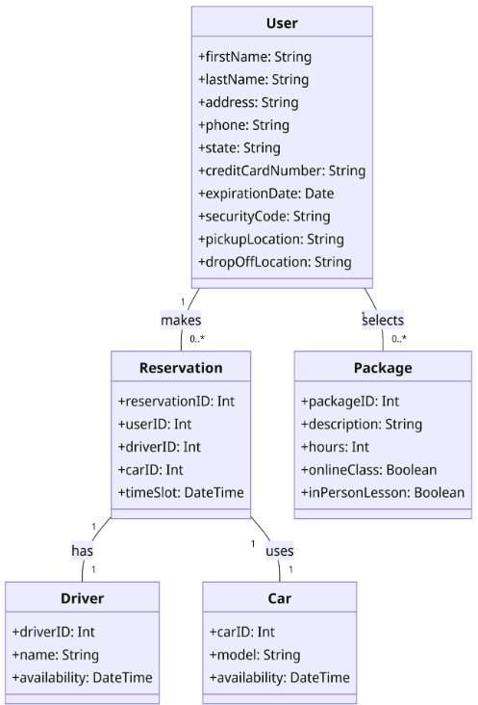

## Technical Requirements

*The system's technical foundation is anchored on a robust set of hardware and software requirements. A powerful server is essential to host the web application, database, and other backend services, ensuring it can handle multiple concurrent users. This is complemented by a backup server, which provides redundancy and disaster recovery. Administrative staff will require workstations with internet access to interact with the system, while mobile devices, such as smartphones or tablets, will enable users to access the system on-the-go.*

*On the software front, a relational Database Management System (DBMS) like MySQL, PostgreSQL, or Oracle is pivotal for storing user data, reservations, and other pertinent information. This is paired with a web server software, such as Apache or Nginx, and backend frameworks like Django, Flask, or Express.js to manage business logic and user authentication. The frontend, responsible for the user interface, will be built on frameworks like React, Angular, or Vue.js. Additionally, cloud storage solutions will be employed for backups and report storage, and an SSL certificate will be crucial to ensure secure data transmission.*

*To streamline development and maintenance, several tools will be integrated. Version control tools like Git will track codebase changes, while Continuous Integration/Continuous Deployment (CI/CD) tools such as Jenkins or Travis CI will automate the deployment process. Monitoring tools like Grafana or Prometheus will be indispensable for overseeing server health and performance, and backup tools will automate data preservation tasks.*

*From an infrastructure perspective, cloud providers like AWS, Google Cloud, or Azure are recommended to ensure scalability and reliability. A Content Delivery Network (CDN) will expedite content delivery for users globally, and a reliable internet connection with redundancy is a must. Additionally, a fortified security infrastructure, including firewalls and intrusion detection systems, will be paramount to safeguard against potential threats.*

*Lastly, the system will benefit from API integration with the DMV to receive timely updates and a payment gateway like Stripe or PayPal for transaction processing. An email service will also be integrated for user communication.*

*In conclusion, the system requires a combination of robust hardware, versatile software, and a secure infrastructure to ensure smooth operations, scalability, and security. Proper planning and investment in these technical requirements will ensure the system's success and longevity.*